

ASSIGNMENT-9

# PYTHON

# **NAME : MADA SRAGVIN KUMAR**

# **MIS NO : 112315097**

# **GROUP : 3**

**YEAR : 2**

**SECTION : A**

# **1:**

import math

class Circle:

def __init__(self,r):

self.r=r

def area(self):

return (math.pi)*((self.r)**2)

c=Circle(5)

print(c.area())

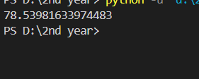

# **2:**

import math

class Circle:

def __init__(self,l,b):

self.l=l

self.b=b

def area(self):

return self.l*self.b

c=Circle(5,8)

print(c.area())

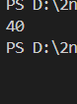

# **3:**

class Myclass:

def __init__(self,n):

self.n=n

def iterator(self):

for i in range(self.n):

if i%7==0:

yield i

c=Myclass(64)

for i in c.iterator():

print(i,end=" ")



# **4:**

class Shape:

def area(self):

return 0

class Square(Shape):

def __init__(self,l):

self.l=l

def area(self):

return self.l**2

sq=Square(5)

print(sq.area())



# **5:**

class My:

def __init__(self,a):

self.a=a

def getString(self,k):

self.a=k

def printString(self):

print(self.a.upper())

m=My("a")

m.getString("abc")

m.printString()

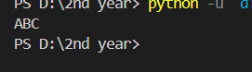

# **6:**

class Person():

def getgender(self):

pass

class Male(Person):

def getgender(self):

print("Male")

class Female(Person):

def getgender(self):

print("Female")

m=Male()

f=Female()

m.getgender()

f.getgender()

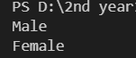

# **7:**

class Package:

def __init__(self,package_id,destination,weight,status):

self.package_id=package_id

self.destination=destination

self.weight=weight

self.status=status

def deliver(self):

self.status="delivered"

class Vehicle:

def __init__(self,vehicle_id,capacity,current_packages):

self.vehicle_id=vehicle_id

self.capacity=capacity

self.current_packages=current_packages

def load_package(self,pack_obj):

total_weight=sum([i.weight for i in self.current_packages])

if total_weight+pack_obj.weight<=self.capacity:

self.current_packages.append(pack_obj)

else:

print("Vehicle is full")

def deliver_packages(self):

for i in self.current_packages:

i.deliver()

class Truck(Vehicle):

def deliver_packages(self):

print("Vehicle Type:Truck")

deli_count=0

for i in self.current_packages:

if i.status=="delivered":

deli_count=deli_count+1

print(f"No. of packages delivered:{deli_count}")

class Drone(Vehicle):

def load_package(self):

for i in self.current_packages:

if i.weight>5:

raise ValueError("This package is more than 5kg")

def deliver_packages(self):

print("Vehicle Type:Drone")

for i in self.current_packages:

if i.status=="delivered":

deli_count=deli_count+1

print(f"No. of packages delivered:{deli_count}")

class DeliverySystem:

def assign_vehicle(self,veh_obj,list_pack):

self.veh_obj=veh_obj

self.veh_obj.current_packages=list_pack

def dispatch(self,veh_obj):

self.veh_obj=veh_obj

for i in self.veh_obj.current_packages:

yield i.deliver()

def main():

pack_list1=[Package("P1","Mumbai",2,"pending"),Package("P2","Chennai",3,"intransit"),Package("P3","Pune",4,"intransit")]

pack_list2=[Package("P4","Mumbai",2,"pending"),Package("P5","Chennai",3,"pending"),Package("P6","Pune",4,"pending")]

tru_obj=Truck("V1-Truck",1000,pack_list1)

dron_obj=Drone("V2-Drone",10,pack_list2)

deli_obj=DeliverySystem()

for i in deli_obj.dispatch(tru_obj):

pass

for i in deli_obj.dispatch(dron_obj):

pass

for i in pack_list1+pack_list2:

print(f"Package->{i.package_id} Status:{i.status}")

main()

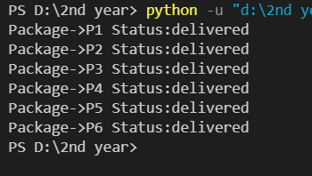

# 

# **8:**

from datetime import *

from random import *

count=0

def sensor_data():

while True:

yield (f"{datetime.now()}",randint(-10,50))

def filter_by_threshold():

for i in sensor_data():

if i[1]>=0 and i[1]<=40:

yield i

mylist=[]

def smooth_temperature():

for i in filter_by_threshold():

mylist.append(i[1])

if(len(mylist)<3):

smoothed_temperature=sum(mylist)/len(mylist)

else:

smoothed_temperature=(mylist[-1]+mylist[-2]+mylist[-3])/3

yield (f"{datetime.now()}",smoothed_temperature)

def convert_to_farenheit():

for i in smooth_temperature():

temperature_farenheit=(1.4*i[1])+32

yield (f"{datetime.now()}",temperature_farenheit)

def main():

for i in convert_to_farenheit():

print(i)

global count

count=count+1

if(count==20):

break

main()

